Tessella Project Number: 6870
Tessella plc 26 The Quadrant, Abingdon Science Park, Abingdon, Oxfordshire, OX14 3YS, UK
T: +44 (0)1235 555511 | F: +44 (0)1235 553301 | E: info@tessella.com | www.tessella.com

Client: STFC & ORNL
Mantid
PM report to Project Management Board
31st May 2012



Document Control
This document is under document control. All members of the distribution list will receive updated copies whenever alterations are made. All other copies are uncontrolled.

Contributors
Name | Role | Company
Nicholas Draper | Author | Tessella

Document Approval
Name | Role | Company

Distribution
Name | Role | Company
Project Management Board Members | Recipient | STFC & ORNL
Mantid Project Repository | Filing | STFC & ORNL

Revision History
Author | Issue | Date | Description
Nicholas Draper | V1.R1.M0 | 28-May-2012 | 1st version written

References
Document | Ref | Date | Details and Version
Short, Medium and long term requirements from ISIS Instrument groups | [SML REQ]] | 04-Aug-2009 | http://svn.mantidproject.org/mantid/trunk/Documents/Requirements/ShortMedLong%20Aug%2009.xls
Project Specification | [PS] |  | http://svn.mantidproject.org/mantid/trunk/Documents/Project%20Management/ProjectSpecification.doc
Stakeholder Plan | [SP] |  | http://svn.mantidproject.org/mantid/trunk/Documents/Project%20Management/StakeholderPlan.doc
Risk Register | [RR] |  | http://svn.mantidproject.org/mantid/trunk/Documents/Project%20Management/RiskRegister.xls

Table of Contents
1 Introduction 4
1.1 Purpose of this Document 4
1.2 Scope of this Document 4
1.3 Context of this Issue 4
2 Election of Chairman of the Project Management Board 4
3 Project Documentation 4
3.1 Stakeholder Plan: 4
3.2 Risk Register: 4
4 Project Status 4
4.1 Development Progress 5
4.2 Current Development team 6
5 NOBUGS 2012 & Mantid workshop 7
6 Testing and release strategy (Jon Taylor) 7
6.1 Patch Releases 7
6.2 Scientist involvement in Testing 7
6.3 Automated system testing 8
7 Collaborating With Other Facilities 8
7.1 Interest from other institutions 8
7.2 Future Growth 9
7.3 Current Collaboration Strategy 9
8 Financial review 9
9 Future Release Dates 9
10 Appendix A 10
10.1 Project Metrics 10
10.2 Ticket completion rate 11
10.3 Project Uptake 12

Introduction

Purpose of this Document
This report details the current state of the Mantid project and summarises the current plans for further development. The project management board will use the information in this report as a basis for the meeting.

Scope of this Document
The scope of this document is limited to the Mantid project, both for progress up to the meeting of the Project management board, and plans for the future.

Context of this Issue
This is the seventh project management report to the Mantid project management board and will provide input to the meeting.

Election of Chairman of the Project Management Board
We thank Robert McGreevy for his time as the Chairman of the PMB. As he has now stepped down we need to elect a new Chairman.

Project Documentation
The project documentation is available through the links below. The Risk Register has been reviewed and updated. The other documents have not been changed since the last PMB meeting.

Stakeholder Plan:
http://svn.mantidproject.org/mantid/trunk/Documents/Project%20Management/StakeholderPlan.doc
Updates:
Changed Lead scientist from Laurent Chapon to Jon Taylor
Update required: Chairman of the PMB to be updated

Risk Register:
https://github.com/mantidproject/documents/blob/master/Project%20Management/RiskRegister.xls
Updates:
Risk 1: Key facility staff leave project – Probability increased following the departure of Janik Zhikovsky, contingency plan expanded.
Risk 11: Difficulties in supporting multiple target platforms - contingency plan extended to consider additional support for Macs.
Risk 13: Software framework is not accepted by end users – Marked complete
Risk 14: Software will not integrate with existing packages – Marked complete
Risk 30: Project internet server fails to provide accepatble performace / reliability – Current controls updated to reflect move to Github
Risk 31: Loss of newtork connectivity to external project resources – Effectiveness of mitigating action changed to improvement required to flag that the local code repository switch over procedures have not been written.
Risk 32: Github fails to provide accepatble performace / reliability for source code control – New Risk.

Project Status

Development Progress
Since the last PMB meeting in October 2011 we have completed two development iterations and released new versions of Mantid on the following dates:
- Release 2.0: 2nd February 2012
- Release 2.0.2: 16th March 2012
- Release 2.1: 4th May 2012
- Release 2.1.1: 1st June 2012
The rate of development within Mantid continued at a fast pace for these two releases; this is supported the project metrics in section 10.2. In particular we have made significant improvements to (among many others):
- User interface
  - Floating windows
  - Instrument view improvements
    - More axes options and multiple curves on the miniplot
    - Peak list display
    - Display of neutronic or physical geometry
  - Prototype Image Viewer
- Framework
  - Live data processing
  - Automated Data Reduction
  - Calibration of PSD based detectors
  - Support for ISIS event Nexus files
  - Multiple file loading and summing.
- Python
  - Added a new Python API, with the ability to switch back to the previous one and a translation script.
  - Support for simultaneous script execution
- Direct Inelastic
  - Diagnostic improvements
  - SofQW correctly rebins taking into account partial areas for corrections and correctly accounting for mask and unobservable areas
- Indirect Inelastic
  - Integration with SofQW changes
  - Improved support for Tosca
  - Support for Basis, tested and validated by instrument scientists
- SANS
  - QXY rewrite for 2D reductions to account for pixel and wavelength dependent corrections.
  - Addition of a data catalog and data stitching capability (ORNL)
- Reflectometry
  - ISIS reflectometry workflow defined and verified
  - User interfaces added for ORNL instruments for magnetic and non magnetic measurements
- Muon
  - Many improvements to allow the release of Mantid to end users and it’s use on the Muon training course.
- VATES
  - Integration with Mantid, and inclusion in a single install package
  - Several new tools
    - Slice Viewer
    - Line Viewer
  - Many improvements to the Vates 3D viewer, including peaks overlay in 3D.
  - New GUI to simplify creating MD workspaces
- Much improved stability of the application

Current Development team
ISIS | SNS
Nicholas Draper (Tessella, PM) | Stuart Campbell (SNS)
Martyn Gigg (Tessella) | Peter Peterson (SNS)
Roman Tolchenov (Tessella) | Mathieu Doucet (SNS)
Owen Arnold (Tessella) | Russell Taylor (Tessella)
Karl Palmen (STFC) | Michael Reuter (SNS)
Anders Markvardsen (70%, STFC) | Andre Savici (SNS)
Alex Buts (80%, STFC) | Vickie Lynch (SNS)
Ronald Fowler (50% eScience) | Dennis/Ruth Mikkleson (SNS, Part time)
Robert Whitely (STFC) | Wenduo Zhuo (SNS)
Peter Parker (STFC) | Shelly Ren (SNS)
 | Jean Bilheaux (SNS)
 | Jose Borreguero (SNS)
Since the last PMB meeting, the ISIS team has remained static which has been productive following the previous period of turnover. We have been recruiting to cover the shortfall in the team, we have one new member of staff and one student joining the team over the next few months. Some other posts however remain unfilled, and recruitment attempts for another graduate post are continuing.
At the SNS Janik Zhikovsky has left the team to move to New York. Handover to existing team members for his areas of expertise has been conducted.

NOBUGS 2012 & Mantid workshop
With NOBUGS in at RAL this year there is the opportunity to combine the Mantid developer workshop together with NOBUGS. However this approach has both advantages and disadvantages:
Advantages | Disadvantages
Combining the events will save on flights | The only available slot for the meeting would be after the conference, leaving only 1 ½ days for the developer meeting
Combining the events may allow more staff from the SNS to travel and contribute | Staff may already be mentally drained after the NOBUGS conference
 | The NeXuS meeting is the week before NOBUGS and involves some of the same staff, leading to a very long set of meetings.
 | Preparation for the Mantid NOBUGS Workshop will clash with preparation for the developer meeting

The other option would be to hold the developer meeting separately from NOBUGS in November or December, allowing it to run over 3 ½ days as it was last year, located either at ORNL or RAL. Overall as project manager I prefer this option, as I think it will allow us to cover more topics, and ensure the building and maintenance of relationships within the team.

Testing and release strategy (Jon Taylor)

Patch Releases
Since Release 2.0 we have introduced patch releases. A patch release carries with it a much smaller overhead of effort and administration. It is designed to release a small number of important fixes, which will allow scientists to stay on the official releases and which crucially have a very low risk of side effects. So far we have released one patch release after each official release, generally one month after the release.
With the small number of tickets we can make use of code reviews as well as testing to verify that the fixes appear correct and have a very low risk of introducing further issues. This is vitally important as with a patch release we do not test widely enough to be able to detect failures in other areas of the code that could be caused by side effects of a correction.
So far this has proved to be a useful and productive process that has delivered vital fixes to our users in a reasonable time frame, and saved many scientists from being forced to use the naturally less stable development version.

Scientist involvement in Testing
For the first time with Release 2.0 we involved the scientists in testing the release. This was possible as the testing and release period was aligned with a long shutdown at both ISIS and the SNS. The initial plan was to conduct our testing as normal, before handing the testing over to instrument scientists from each group to validate the results and raise any urgent issues or vital missing functionality.
We had allowed for one week of scientist testing, followed by one week for fixing any issues raised. This proved optimistic, and sufficient issues were raised that two weeks of development were required to fix them. Overall this was a very productive exercise and I propose that we repeat this process with one release each year, ideally when long shutdowns of the facilities coincide.
There were areas of this process however that were not ideal:
The level of involvement of the instrument scientists at the two facilities was not equal, while all of the instrument scientists on both scientific steering committees were asked to contribute; only Garrett Granroth participated from the SNS. His contribution was greatly appreciated and led to several rapid advance in the support for his work, but I feel we missed an opportunity to repeat this with other scientific groups. If we were to run this process again a greater effort must be made to engage the instrument scientists in the testing process.
Due to the imbalance in the testing there was a similar imbalance in the workload for the development team. Staff at ISIS were inundated with work both supporting the testing and implementing fixes, while many staff at the SNS had no work related with the release to do, and moved onto work for release 2.1. As such it appeared to the SNS based team that the release was dragging on, while the ISIS team were extremely busy. This problem would not be so apparent if we can level the testing input more effectively.

Automated system testing
We have recently encountered a collection of problems that have been caused by developers at one facility not considering or testing sufficiently for differences at the other facility. While it is important that all of our developers consider the needs of all facilities involved it is only natural that this will occasionally happen, unless we put in sufficient support to catch these errors before they are released.
The only mechanism that can realistically catch this form of errors is our automated system tests. We currently have 43 automated system tests, but our overall coverage is still low. I suggest that as a project we make an effort to gather at least one system test for every instrument that uses Mantid, and where possible one for every common usage scenario for every instrument. With this level of coverage developers will get timely feedback is a change has inadvertently affected the vital workflows of other instruments.

Collaborating With Other Facilities

Interest from other institutions

Reactor Sources

ILL
ILL have recruited a member of staff to work on evaluating Mantid over the next year, and have invited Jon Taylor and I to give a talk about the current status and plans of Mantid next month in order to kick off the situation. The potential adoption of Mantid at the ILL is a potentially sensitive subject after other software project experiences, and the sensitivities of the supporters of the various existing systems, so we have to tread softly here.

Julich and HDRI
No further contact.

ANSTO
No further contact

Pulsed Neutron sources

J-Parc
Masa Arai has been in contact with Andrew and Uschi about sending over someone to learn more about Mantid and evaluate its usefulness to them. Currently he plans to come over in September for a month, ending with the NOBUGS conference.

ESS
Stig Skelboe has acquired funding to recruit a member of staff to improve Mantid / McStas integration, Peter Willendrup has an advert out for recruitment with a deadline of June the 11th. This is a set of tasks we have discussed over the last year or so when we have met at meetings and at ISIS, and would be a good way for them to learn more about Mantid.
I have also been helping Thomas Holm-Rod with creating estimates of the effort involved to develop data reduction either using Mantid, or starting afresh.

CSNS
As part of our attempts to recruit at ISIS we spoke to one of the software developers at the CSNS. They are interested in Mantid, and are in the process of convincing there senior management to put in an official request to join the collaboration.

Future Growth
Given the level of active interest in either collaborating in a small scale or joining the Mantid collaboration as a full partner we should consider the following:
- How wide do the members of the PMB see the Mantid collaboration growing? Should we stay as a two facility collaboration, look for adoption across all neutron facilities or something in between.
- Who ultimately would make the decision on the behalf of each member facility whether another partner should join the collaboration. If that is not the members or the PMB then we need to consider how to put forward our views for consideration.
- What our recommendations as project board would be for each facility.

Current Collaboration Strategy
The current strategy that has been approved in previous meetings of the PMB has so far been:
- We will not explicitly encourage other institutions to adopt Mantid, but we will respond to facilities that contact us.
- In order that they may properly evaluate Mantid, we will provide assistance to create a loading routine for one format of their data, and one instrument definition.
- We explain for anyone to join the collaboration as an equal partner it would need to be agreed by the PMB, and they would need to sign a similar Memorandum of Understanding that exists between ISIS and ORNL.
- Smaller collaborations are possible, but those developments would not benefit from significant amounts of time from the development team, and would not get representation at the PMB.

Financial review
Details of the project financial state is included in Appendix A and B. For ISIS the contract is currently estimated to last until November 2012.
The current order for Russell Taylor at ORNL is currently estimated to end in December 2013, and is current funded until late August 2012.

Future Release Dates
The planned release dates for the rest of this year would be:
- 6th July 2012
- 15th October 2012
This does not include patch releases.

Appendix A

Project Metrics
SubProject | Files | Statements | %comments
Mantid Framework | 3,108 (2,128) | 332,874 (272,793) | 19.9 (19.6)
MantidPlot | 724 (535) | 112,862 (96,905) | 15.6 (13.7)
VATES | 278 (200) | 11,782 (9,338) | 21.3 (21.4)
Total | 4,110 (2,863) | 457,518 (379,036)
The metrics are defined as follows:
Metric | Description
Files | The number of .h, .cpp and *.py files (not including third party libraries) included in the analysis.
Statements | The number of valid C++ statements, loops, conditional statements and pre processor directives are included.
% Comments | This is the percentage of the overall number of lines which are comment lines. I have not directly reported the number of lines in the file, but a good rule of thumb is that it is roughly twice the number of statements.
The Mantid Framework code has significantly grown since the last PMB (the previous values are in brackets), as would be expected with the addition of the new functionality described earlier.

Ticket completion rate
Development on Mantid is performed in two-three month iterations, each of which ends with an official release of the software. Longer pieces of work sometimes have to span a development iteration in which case that piece of work appears as completed only in the iterations when it becomes available to the users.
With the last two releases we have introduced patch releases to solve issues that become apparent after the main release.
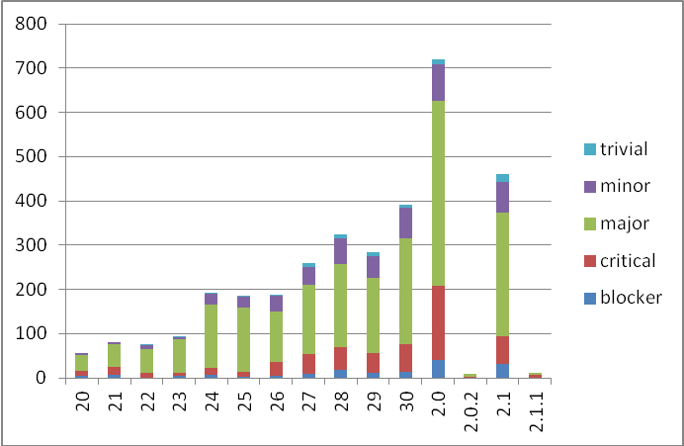

Project Uptake

Mailing List Subscriptions
Our software download site no longer requires people to register to a mailing list in order to download the installer packages. A simple analysis of the email domains shows that while the majority of the users are from ISIS, followed by ORNL and we have had some interest from other institutions and universities.
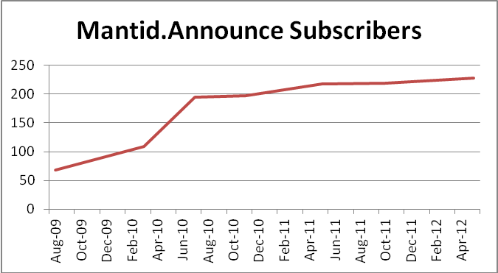
Summary
Date | Users
Aug-09 | 68
Mar-10 | 109
Jul-10 | 195
Nov-10 | 197
May-11 | 217
Oct-11 | 219
May-12 | 228

Current domain breakdown (2+)
Domain | 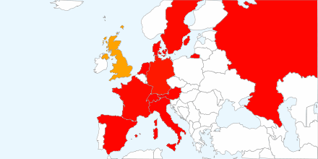  count
stfc.ac.uk | 73
ornl.gov | 28
gmail.com | 21
helmholtz-berlin.de | 9
swansea.ac.uk | 2
sheffield.ac.uk | 2
imperial.ac.uk | 2
caltech.edu | 2
esss.se | 2
owlpic.com | 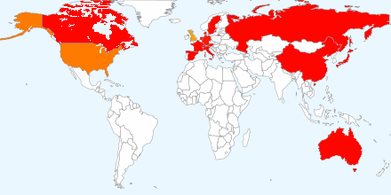  2
tudelft.nl | 2
ill.fr | 2
isc.cnr.it | 2
anl.gov | 2
bath.ac.uk | 2
psi.ch | 2
uwstout.edu | 2
ansto.gov.au | 2
hmi.de | 2
j-parc.jp | 2
 | 2
  lanl.gov

Software Downloads
Since December 2010 when we removed the requirement to subscribe to the mailing list, we began to track downloads. We record the ip-address along with the file downloaded, due to the nature of facility users sharing ip-addresses it is not possible to only report on unique ip-addresses, but the total count of downloads is interesting although too much should not be read from it. I should also stress that this does not currently include Unix RPM downloads via the ISIS or SNS Red Hat repositories.
